**Motor Vehicle Theft in New Zealand.**

*Amantay Abdurakhmanov*

**Abstract**

Crimes are ugly but inevitable part of our lives. Thousands of them happen every day and majority of people have suffered from criminal activity at least once. Motor Vehicle Theft (MVT) is one of the significant types of crimes with particularly little attention in science literature and low interest in researches.

In this work I have analysed daily snapshots of data taken from the *Stolen vehicle lis*t, which is a snapshot of data taken from the Police vehicle of interest database (New Zealand Police, a). Data has been collected from July 25, 2019, to September 24, 2019, to get better understanding of MVT and recovery patterns in New Zealand. The result findings showed more than 70% recovery rate. In addition, it is discovered that motorcycles and trailers are significantly more preferable for permanent crime than cars.

**Introduction**

MVT makes a significant contribution to the crime statistics of New Zealand – almost eleven percent of victimisations reported by Recorded Crime Victims Statistics (RCVS)(New Zealand Police, c; b). There are few amounts of research on MVT, which may be due to its similarity to other property thefts (Clarke & Harris, 1992a). However, MVT has its own specific attributes. For instance, motor vehicle (MV) is a unique type of property which can be easily counted and registered. Another feature of MVT is the highest return level of all stolen property, for instance, 59% of stolen MV in the USA in 2006 were recovered (Cherbonneau & Wright, 2011). Unique above characteristics make MVT a convenient object for statistical analysis.

**Literature review**

There are several classification schemes of MVT based on offenders’ behaviour in criminological studies. One of the first was developed by Hall J. who separates those in two classes with amateur joyriders on one side and professional auto thieves on the other (Hall, 1952).

The more comprehensive approach to understand MVT was offered by McCaghy C. et al. with five different motivations: 1) most common *joyriding* which “denotes essentially recreational, non-utilitarian, short-term use of cars”; 2) s*hort-term transportation* with the car stolen for a short-term use primarily for going from one place to another particular location; 3) long-term transportation with intend to retain MV for personal usage; 4) p*rofit* with stealing cars for further resell for profit (by parts or whole); 5) c*ommission of another crime* with cars stolen especially for use in next crime.(McCaghy, Giordano, & Henson, 1977, pp. 378-380).

Based on the classification above Herzog S. proposed eight types of theft motivation with added *equipment supplement*, *insurance fraud*, *dismantling of car parts*, *assignment of new identity* and *transfer across national borders,* and combined short- and long-term transportation into a single type (Herzog, 2002).

Clarke R. and Harris. took a different approach with three-part motives classification: *temporary use*, *permanent retention*, and *stripping (Clarke & Harris, 1992a).*

All the authors agree that joyriding is the most common type of MVT, because up to half of the stolen MV are recovered within three days after theft, and probability of recovering drops sharply over time (Barnett, 2000).

Many authors agree that MV recovery status might be used as an acceptable measure of temporary and permanent theft (Clarke & Harris, 1992a, 1992b; Roberts & Block, 2013; Tremblay, Clermont, & Cusson, 1994). Recovery of MVT highly depends on the motives of theft, therefore MV stolen for profit (i.e. professional crime) are most likely not to be ever recovered, in contrast with those which are stolen for temporary use (e.g. for joyriding). Due to limitations of the analysed data this simple dichotomy classification *temporary/permanent* was used for further assumptions in this work.

Most of the found modern statistical studies are focused on vehicle’s geospatial location and modelling origin-destination point patterns recovery, making heat maps, and discovery of near-repeat patterns. (Block & Fujita, 2013; Lockwood, 2012; Piza, Feng, Kennedy, & Caplan, 2017; Roberts, 2012; Youstin, Nobles, Ward, & Cook, 2011).

Some researches applied statistical models on time-based recovery patterns, such as survival model (Barnett, 2000), logistic regression model (Herzog, 2002; Roberts, 2012), F-test (Roberts & Block, 2013).

The found studies have been conducted in the United States, Canada, Australia, Israel and the United Kingdom. No previous researches analysing MVT in New Zealand have been found. This paper used data from the snapshots of vehicle of interest database provided by New Zealand Police. Despite of some limitations such as a few inaccuracies in the data, it can be analysed after cleaning, and can provide a relevant reflection of the reality.

**Research question**

1. Estimate and analyse recovery rates of stolen MV
2. Examine the pattern of MVT and recovery days by day of the week
3. Analyse recoveries by district and MV production date.

**Research Design and assumptions**

Stolen vehicle list (New Zealand Police, a) is the main source of data used in this study which is “a snapshot of data taken from the Police vehicle of interest database”. The list is available for download as a CSV (comma separated vales) format and consists of eight columns. Unfortunately, columns are not named, but content can be understood by the data. As a result of daily file download 60 files were collected for further analysis. After analysing those files, the following conclusions were made.

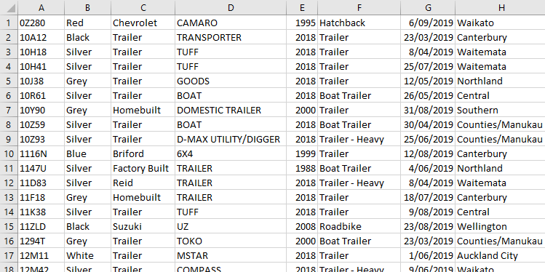

Figure 1. Screenshot of the sample data from original SCV file

1. Sequence of columns: A) *MV registration number* B) *MV colour* C) *MV make* D) *MV model* E) *MV production date* F) *MV type* G) *MV stolen date* H) *MV stolen place*.
2. *MV Stolen place* in those files is a nominal value of New Zealand police districts which are: *Auckland City*, *Bay of Plenty*, *Canterbury*, *Central*, *Counties/Manukau*, *Eastern*, *Northland*, *Southern*, *Tasman*, *Waikato*, *Waitemata*, *Wellington*.

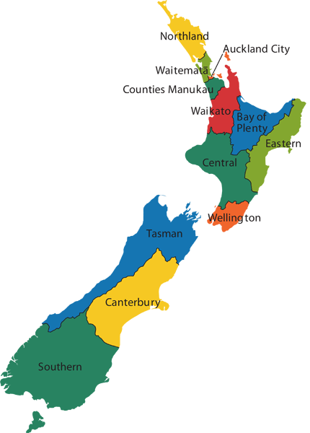

Figure 2. Police districts map. Source: https://www.police.govt.nz/about-us/structure/districts

1. *List date* can be calculated for each file as maximum date of *MV Stolen date* (column G) that represents the date of the latest MVT in each file.
2. During the analysed period the number of records in each file was almost identical with minimum 3931 on August 30 and 4028 on August 05. The explanation is that recovered MV are removed from the stolen list. Besides recovered ones, those that were stolen more than 180 days ago and have not been recovered are removed, too.

For further analysis the obtained files must be combined in a single aggregated dataset with calculated value of *MV recovery date,* that is calculated for each MV as the last *List date* when it exists in the list. *MV recovery days* are calculated by subtraction “*recovery date – stolen date”*. *Output* result is equal to 1 if MV was recovered (*recovery days* value has been defined and not greater than 180, because 180 – is a threshold date for the list set by source). Aggregated dataset has been cleared by elimination of rows with empty values in any column.

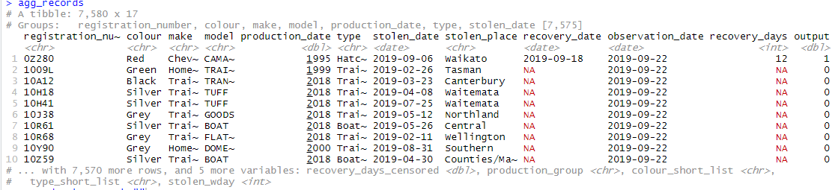

Figure 3. R Studio console screenshot represents structure of aggregated dataset

Obtained dataset became a source for separate datasets: one with all recovered MV (*output* = 1) and the second with those MVT that happened during the period of collecting daily snapshots (*stolen date* >= “2019-07-25”).

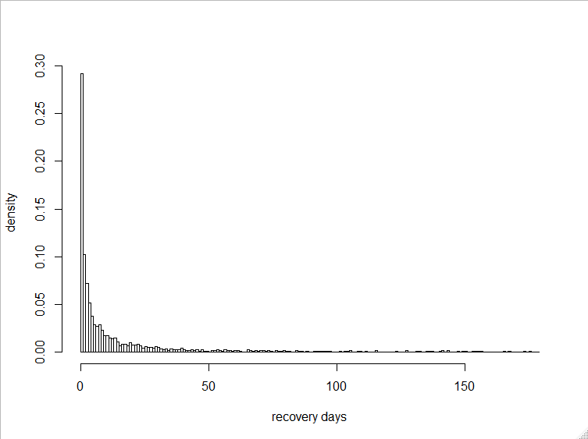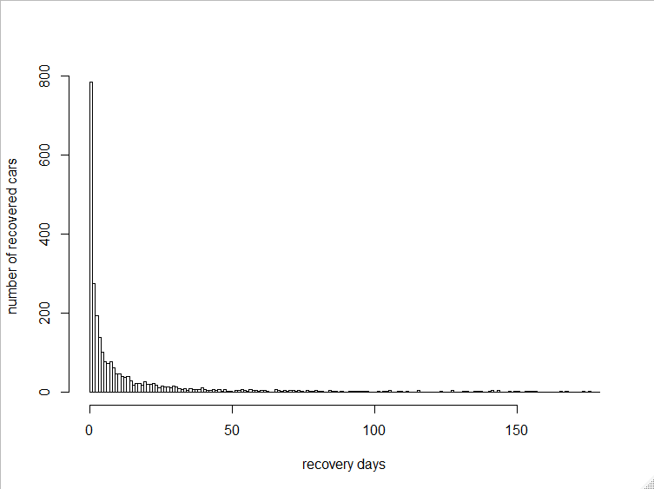**Findings, Analysis and Discussion**

Figure 5. Density histogram in aggregated dataset

Figure 4. Frequency histogram of recovery days in aggregated dataset

22% of stolen (30% of recovered) MV were found in 1 day, 34% of stolen (47% of recovered) MV were found in 3 days, 45% of stolen (62% of recovered) MV were found within the first week and 62% of stolen (86% of recovered) were found within the first 30 days with overall recovery rate 73%. That recovery pattern confirms the thesis that probability of return extremely decreases over time.

The tables below depict absolute values of MVT in each region and recovery proportion.

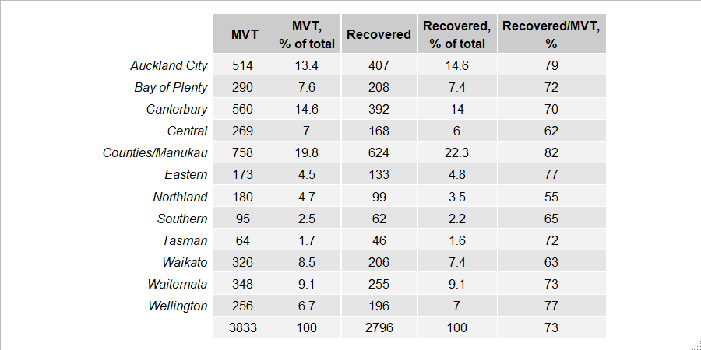Figure 6. MVT and recoveries for the analysed period

Another possible approach of measuring is deriving those numbers per 10000 of population.

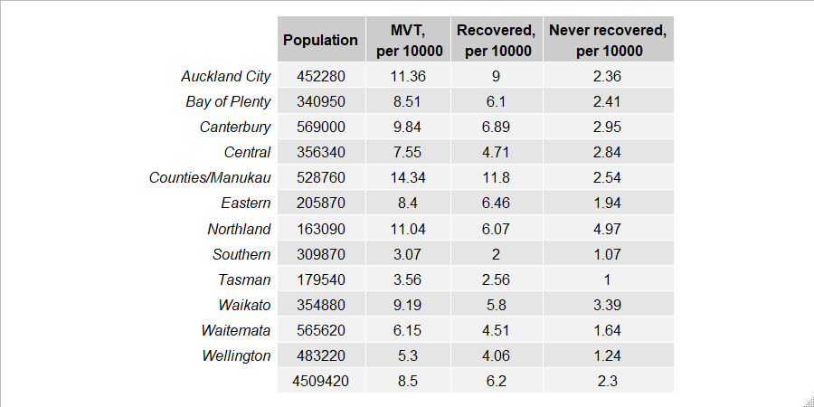“Counties/Manukau” demonstrates the highest level of MVT (both of absolute numbers and per 10,000 population). But simultaneously the region has the highest level of recovery with never recovered number per 10,000 near to average. In contrary to that pattern, Canterbury has average level of MVT with poor recovery which leads to the highest never recovered number.

Figure 7. Population by Police districts in 2014 according to Calendar Populations for Crime Statistics (Statistics New Zealand, 2015)



Figure 8. Percent distribution of MVT by Day of the Week:

Mondays show higher frequency of thefts which is consistent with general pattern of “*joyriding*” temporary MVT, that usually happen on weekends.

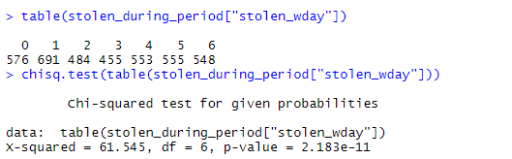

Figure 9. Screenshot of the results of Pearson’s chi-squared test performed on weekday distribution

Stolen status of MV can be viewed as a state of “survival” in terms of statistical survival analysis (Barnett, 2000). Kaplan-Meier estimator of the survival function (Kaplan & Meier, 1958) was applied on the dataset classified by MV production date (older than 1990, 1990-1999, 2011-2015 and 2016+) using R-package survival (Therneau & Lumley). Obtained survival curve was plotted using R-package survminer (Kassambara , Kosinski, & Przemyslaw).

Figure below shows that older (1989 and older) and new (2016 and newer) MV are more preferable by thieves and are recovered significantly less often than MV produced between 1990 and 2010.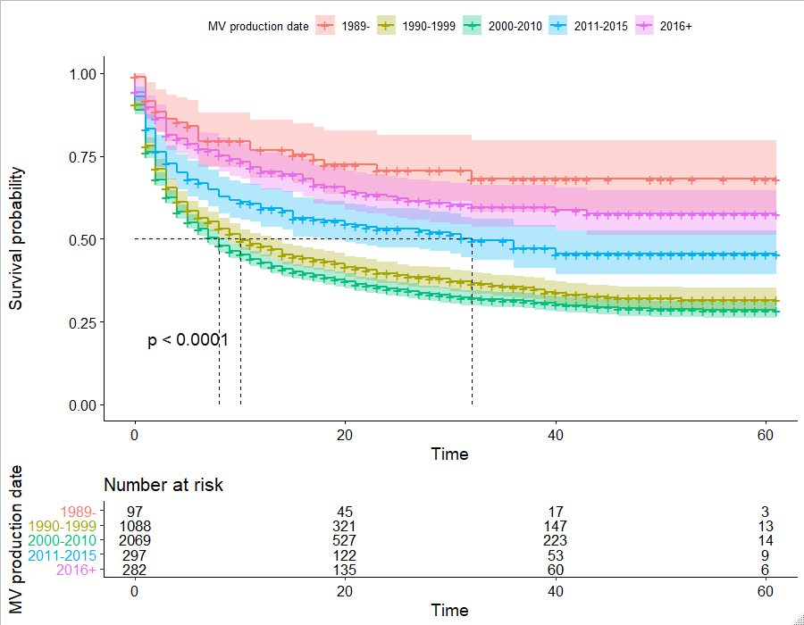

Figure 10. Survival curve depending on MV production date with confidence intervals.

In addition, survival curve was applied on the data set divided by MV type. The obtained plot clearly shows that motorcycles and trailers are noticably more likely to never return than other types of MV.

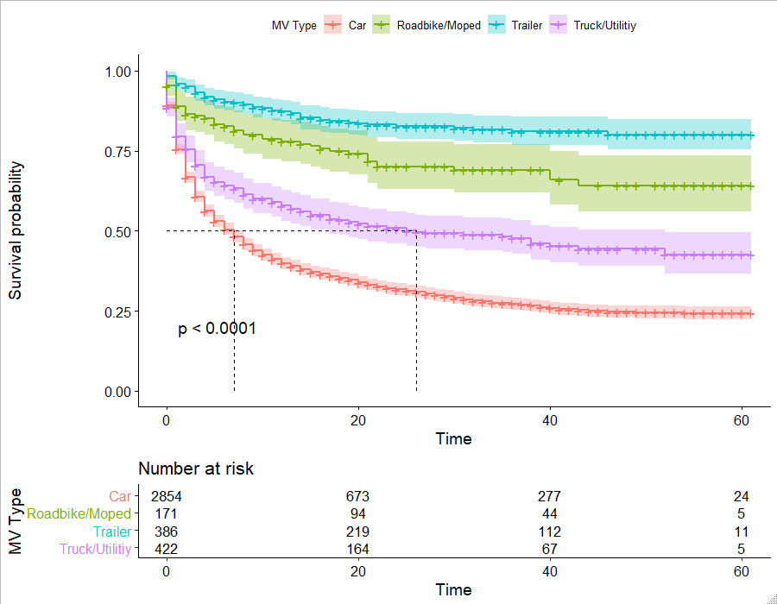

Figure 11. Survival curve depending on MV type with confidence intervals

**Conclusion, Limitations & Future Work**

The objective of present study was to measure MVT in New Zealand trying to estimate stolen/recovery patterns and types of vehicle preferred by thefts for temporary and permanent usage. Discovered patterns clearly indicate that majority of MVT can be classified as temporary with preference of cars produced between 1990 and 2010. Permanent MVT are concentrated on new motorcycles (2016 and after) and old trailers (1989 and earlier).

Unfortunately, these observations are limited by two months period from 25/07/2019 to 24/09/2019 when snapshots have been collected daily. It would be interesting to examine data for at least one whole year, and therefore I have asked the New Zealand Police for a complete dataset from the beginning of 2017.

References

Barnett, S. (2000). Analysis of Motor Vehicle Theft Using Survival Model. 283.

Block, S., & Fujita, S. (2013). Patterns of near repeat temporary and permanent motor vehicle thefts. *Crime Prevention and Community Safety, 15*(2), 151-167. Block2013. <https://doi.org/10.1057/cpcs.2013.1>

Cherbonneau, M., & Wright, R. (2011). *The Oxford handbook of crime and public policy, edited by Tonry, Michael.* : Oxford University Press.

Clarke, R., & Harris, P. (1992a). Auto Theft and Its Prevention. *Crime and Justice, 16*, 1.

Clarke, R., & Harris, P. (1992b). A rational choice perspective on the targets of automobile theft. *Criminal Behaviour and Mental Health*(Issue 1), 25.

Hall, J. (1952). *Theft, law, and society*: Bobbs-Merrill Indianapolis.

Herzog, S. (2002). EMPIRICAL ANALYSIS OF MOTOR VEHICLE THEFT IN ISRAEL, 1990-97. *British Journal of Criminology, 42*(4), 709.

Kaplan, E. L., & Meier, P. (1958). Nonparametric estimation from incomplete observations. *Journal of the American statistical association, 53*(282), 457-481.

Kassambara , A., Kosinski, M., & Przemyslaw, B. *survminer: Drawing Survival Curves using 'ggplot2'*. Retrieved from <https://cran.r-project.org/web/packages/survminer/index.html>

Lockwood, B. (2012). The presence and nature of a near-repeat pattern of motor vehicle theft. *25*, 38-56. <https://doi.org/10.1057/sj.2011.5>

McCaghy, C., Giordano, P., & Henson, T. (1977). AUTO THEFT Offender and Offense Characteristics. *Criminology, 15*(3), 367.

New Zealand Police. *Crime at a glance* (c). Retrieved from <https://www.police.govt.nz/about-us/publication/crime-glance>

New Zealand Police. *Recorded Crime Victims Statistics (RCVS) and Recorded Crime Offenders Statistics (RCOS)* (b). Retrieved from <https://www.police.govt.nz/about-us/publications-statistics/data-and-statistics/policedatanz>

New Zealand Police. *Stolen vehicles list* (a). Retrieved from <https://www.police.govt.nz/stolenwanted/stolen-vehicles>

Piza, E., Feng, S., Kennedy, L., & Caplan, J. (2017). Place-based correlates of Motor Vehicle Theft and Recovery: Measuring spatial influence across neighbourhood context. *Urban Studies, 54*(13), 2998-3021. <https://doi.org/10.1177/0042098016664299>

Roberts, A. (2012). Motor Vehicle Recovery: A Multilevel Event History Analysis of NIBRS Data (Vol. 49, pp. 444-467).

Roberts, A., & Block, S. (2013). Explaining Temporary and Permanent Motor Vehicle Theft Rates in the United States A Crime-Specific Approach (Vol. 50, pp. 445-471).

Statistics New Zealand. (2015). *Calendar Populations for Crime Statistics*. Retrieved from <http://archive.stats.govt.nz/~/media/Statistics/browse-categories/people-and-communities/crime-justice/recorded-crime/police-dist-pop-est-cal-yr/SNZ%20Calendar%20Populations%2004Mar15.xls>

Therneau, T., & Lumley, T. *survival: Survival Analysis*. Retrieved from <https://cran.r-project.org/web/packages/survival/index.html>

Tremblay, P., Clermont, Y., & Cusson, M. (1994). Jockeys and Joyriders - Changing Patterns in Car Theft Opportunity Structures. *British Journal of Criminology*(Issue 3), 307.

Youstin, T. J., Nobles, M. R., Ward, J. T., & Cook, C. L. (2011). Assessing the Generalizability of the Near Repeat Phenomenon. *Criminal Justice and Behavior*(Issue 10), 1042.